Discussion Plan
In the Discussion Plan, you will identify two sources from the Introduction and find four new, peer-reviewed sources to help you set your results in context.
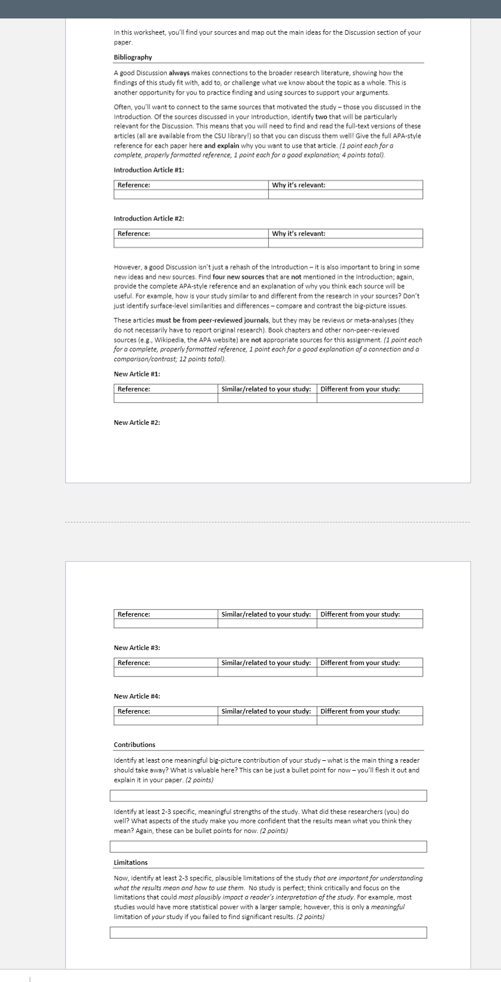

Fill in the blank: Findings Check
Hypothesis 1: The main effect of simulator was not was/was not as I predicted; participants in the supervisory control group showed better outcomes compared to participants in the transparent automation group .
The effect size was eta squared with a value of ___.
This main effect simulator was significant. Based on a(n) two-way ANOVA, the test statistic was of 0.33 with 2(df1) and 294(df2) degrees of freedom and the p-value was < .05.

Hypothesis 2: The main effect of transparency was not as I predicted; participants in the simulator showed better outcomes compared to participants in the transparent automation group .
The effect size was eta squared with a value of ____.
This main effect transparency was significant . Based on a(n) two-way ANOVA, the test statistic was Cohen’s d of with 2_ and 294 degrees of freedom and the p-value was < 0.1.

Hypothesis 3: The interaction between simulator and transparency was in the form I predicted; the effect of simulator was strongest for participants in the level of transparent automation group group(s) and weaker for participants in the level of non-transparent of automation group.
The effect size was eta squared with a value of ___.
This main effect was significant/not significant. Based on a(n) Two-way ANOVA, the test statistic was eta-squared of 0.33 with __ and __ degrees of freedom and the p-value was < .05.

Hypothesis 4: The covariate, was not related to the dependent variable in the direction I predicted; the covariate was positively associated with the DV, according to the line of regression, with a value of value of your coefficient.
The effect size was multiple R-squared with a value of .05.
This effect was significant/not significant. Based on a(n) specific name of your analysis, the test statistic was name and value of your test statistic with df value #1_ and df value #2 degrees of freedom and the p-value was your p-value.

